Given the head of a linked list and an integer val, remove all the nodes of the linked list that has Node.val == val, and return *the new head*.

**Example 1:**

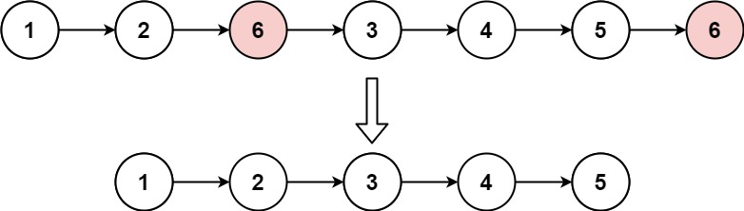

Input: head = [1,2,6,3,4,5,6], val = 6  
Output: [1,2,3,4,5]

**Example 2:**

Input: head = [], val = 1  
Output: []

**Example 3:**

Input: head = [7,7,7,7], val = 7  
Output: []

**Constraints:**

* The number of nodes in the list is in the range [0, 104].
* 1 <= Node.val <= 50
* 0 <= val <= 50